Automatic Character Recognition in Porcelain Ware
David Álvarez, Santiago Garrido, Luis Moreno¹⁾, Adriana Birlutiu, and Manuella Kadar²⁾
¹⁾ Department of Systems and Engineering, University Carlos III of Madrid, Leganés, Spain {dasanche,sgarrido,moreno}@ing.uc3m.es
²⁾ Department of Computer Science, University 1 of December 1918, Alba Julia, Romania
adriana.birlutiu@gmail.com, manuellakadar@yahoo.com

Summary: This paper presents an automatic serial number recognition based on computed vision techniques. The approach uses standard algoritmhs for digit segmentation and a deep learning approach for the recognition. The system is developed within a project in collaboration with one of the biggest porcelain ware producer in Europe.

Keywords: Deep Learning, Computer Vision, Digit Recognition.

Motivation

While manufacturing any type of porcelain ware, in the case of a detection of a defect, the error is usually propagated to all the series in a production. The root of the problem can be found in many different parts of the process: the raw materials [1] (clay, feldspar, or silica) might be contaminated or any of the processing steps [2] (crushing, mixing, forming the shape, glazing, firing, painting) might contain a malfunctioning machine which provokes the defect. In order to identify the parts of the process, characters (numbers and letters) are engraved in the porcelain ware. This work attemps to detect and recognise these symbols in order to help in the quality control process, aiming to facilitate defect measurements and rectifications in the porcelain ware manufature.

As far as the authors know, there is not bibliographic research literature available of computer vision solutions for plate inspection, other than extracting texture features for detecting defects on ceramics [3], [4]. However, it is an emerging technology in the global ceramic industry [6], and a standardization on the determination of ceramics quality has been established by the International Standard Organization (ISO) in the SNI ISO 10545-2:2010 document [7].

The work presented in this paper is tested using round plates in which the symbols are engraved in the backside. The images of the plates are taken in a real manufacturing line, without controlling light conditions. An example of an original image can be seen in the left side of Figure 1.

The engraved symbols are organized in 3 groups of letters which have 4, 3, and 1 symbols each. In order to segment the individual symbols, the geometrical properties of the plates are searched in the image in a sequential manner. First, 8-connected components of contiguous regions of a binarized version of the image are studied, measuring their area and perimeter. This allows us to select the largest area (corresponding to the plate) and find the inner circle using equation 1. In the central image of Figure 1, the inner circle is drawn in red.

(1)

The inner circle area is again binarized, the resulting edges are enlarged and, again, 8-connected components of contiguous regions are studied to detect the 3 groups of letters, as shown in upper part of the right side of Figure 1. Then, in each group, the projection of the letters into the X-axis is studied to separate the individual letters, as shown in lower part of the right side of Figure 1.

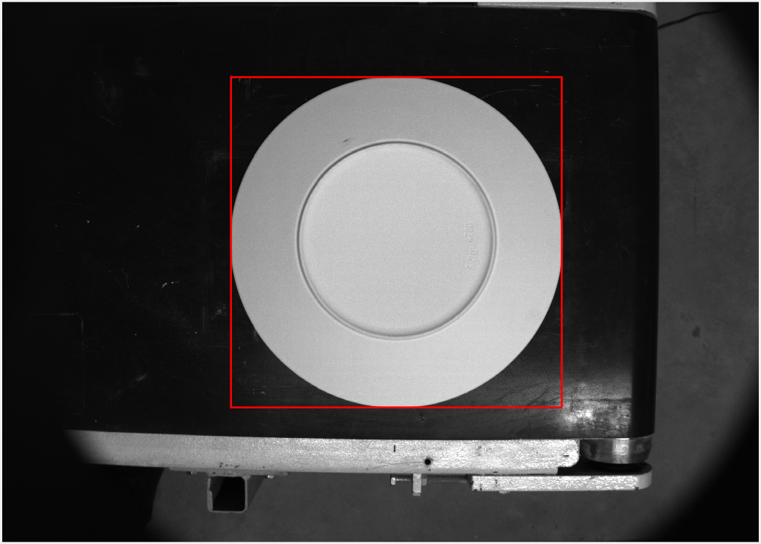
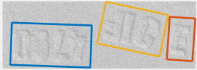
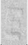
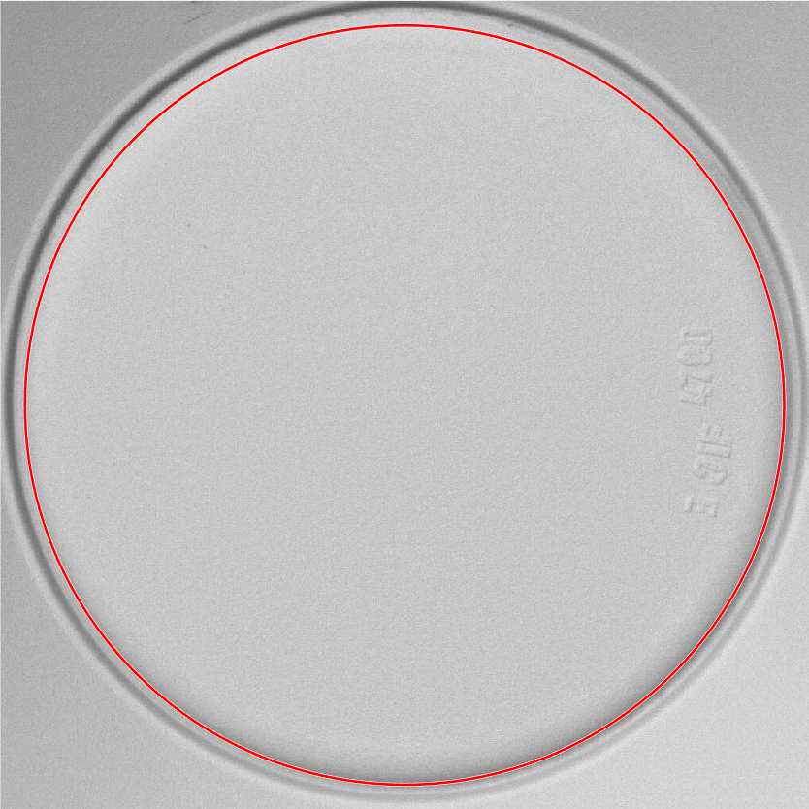

Figure 1: Segmentation process of round plates.

Results
All the individual collected characters are manually sorted and labeled into their respective category, resulting in 18 different characters. With the resulting database, a Convolultional Neural Network (its characteristics are shown in Figure 2) is trained using the 75% of the examples, while the rest is used for testing. This way, we are able to correctly classify 98% of the database.
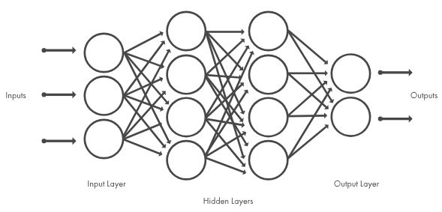
ImageInputLayer = [53 26 1]
convolution2dLayer = ( [7,5] , 26 )
reluLayer
maxPooling2dLayer(2,'Stride',2)
fullyConnectedLayer(18)
softmaxLayer
Figure 2: Example of two figures simply placed in an invisible two-column table.
We think the results prove that the chosen technique is appropriate for achieving good recognition results and, therefore, plan to extend the work to more types of porcelain ware and more symbols to be distinguish.
This study is supported by the Executive Unit for Financing Higher Education, Research and Innovation, through Project 50BG/2016, SIVAP Intelligent System based on Machine Learning and Computer Vision for the Optimization of the Manufacturing Process of Porcelain.

References
- Campbell, James E. The Art and Architecture Information Guide Series, vol. 7: Pottery and Ceramics, A Guide to Infonnation Sources. Gale Research, 1978.
- Jones, J. T. and M. F. Bernard. Ceramics, Industrial Processing and Testing. Iowa State University Press, 1972.
- M.S. Mostafavi. 2006. A New Method in Detection of Ceramic Tiles Color Defect Using Genetic C-Means Algorithm. In Proceeding of World Academic of Science, Engineering and Technology. pp. 168-171.
- Ahmadyfard. 2009. A Novel Approach for Detecting Defects of Random Textured Tiles Using Gabor Wavelet. World Applied Sciences Journal. 7(9): 1114- 1119.
- Silveira, J., Ferreira M.J., Santos C., Martins T. Computer Vision Techniques Applied to the Quality Control of Ceramic Plates. Journal of Physics Conference Series, p. 2009.
- 2010. Ceramic Tiles - Part 2: Determination of dimensions and surface quality. National Standart Corporation, SNI ISO 10545-2.

